EXPERIMENT- 12
Perform Perspective Transformation on the Image
Aim
To write a Python code to perform perspective transformation on an image using OpenCV for changing the viewing perspective of the image.
Input Image
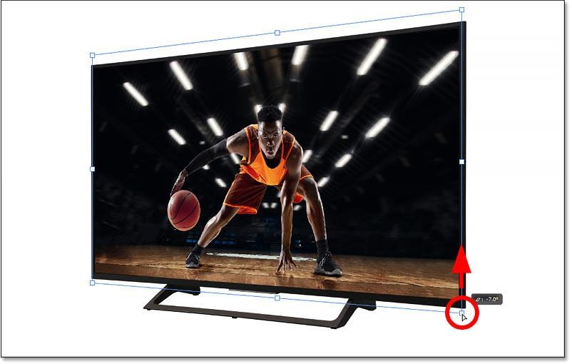
Code
import cv2
import numpy as np
from google.colab.patches import cv2_imshow
from google.colab import files
uploaded=files.upload()
image_path=list(uploaded.keys())[0]
image=cv2.imread(image_path)
if image is None:
print("Error: Image not found")
else:
rows,cols=image.shape[:2]
pts1=np.float32([[50,50],[200,50],[50,200],[200,200]])
pts2=np.float32([[10,100],[200,50],[100,250],[200,200]])
matrix=cv2.getPerspectiveTransform(pts1,pts2)
transformed_image=cv2.warpPerspective(image,matrix,(cols,rows))
print("Original Image")
cv2_imshow(image)
print("Perspective Transformed Image")
cv2_imshow(transformed_image)
Output Image
Perspective Transformed Image
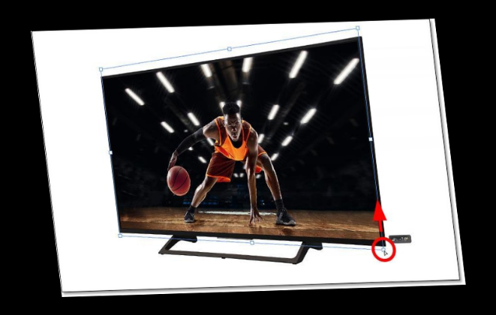
Result
Thus, perspective transformation was successfully performed on the image using OpenCV.

